Module Four: Activity
Bayyan N Rushdan
Department of Computer Science
Southern New Hampshire University
CS 630 Software Testing and QA
Dr Ben Torrales
August 2, 2026

Module Four: Activity
API Interface Risk Analysis and Edge Case Testing
Reflection
This activity demonstrated that effective API testing requires more than verifying expected inputs and outputs. Before creating any tests, I reviewed the API documentation, the available endpoints, the Flask server implementation, and the count_words() function to understand how requests were accepted, validated, and processed. Examining the source code helped identify where input validation already existed and where potential weaknesses remained. For example, the API correctly validated missing query parameters and missing JSON fields, but it did not verify that the text parameter was actually a string before passing it to the word-counting function. That observation helped guide the design of several edge-case tests. Reviewing both the GET and POST endpoints helped identify how the API validated query parameters and JSON request bodies before processing user input.
Risk Assessment
Risk | Likelihood | Impact | Recommendation
Invalid input types | Medium | High | Validate input type before processing
Extremely large requests | Low | Medium | Set maximum request size
Malformed JSON | Medium | Low | Return descriptive parsing errors
Missing required parameters | High | Low | Current validation is appropriate

Test Execution Results
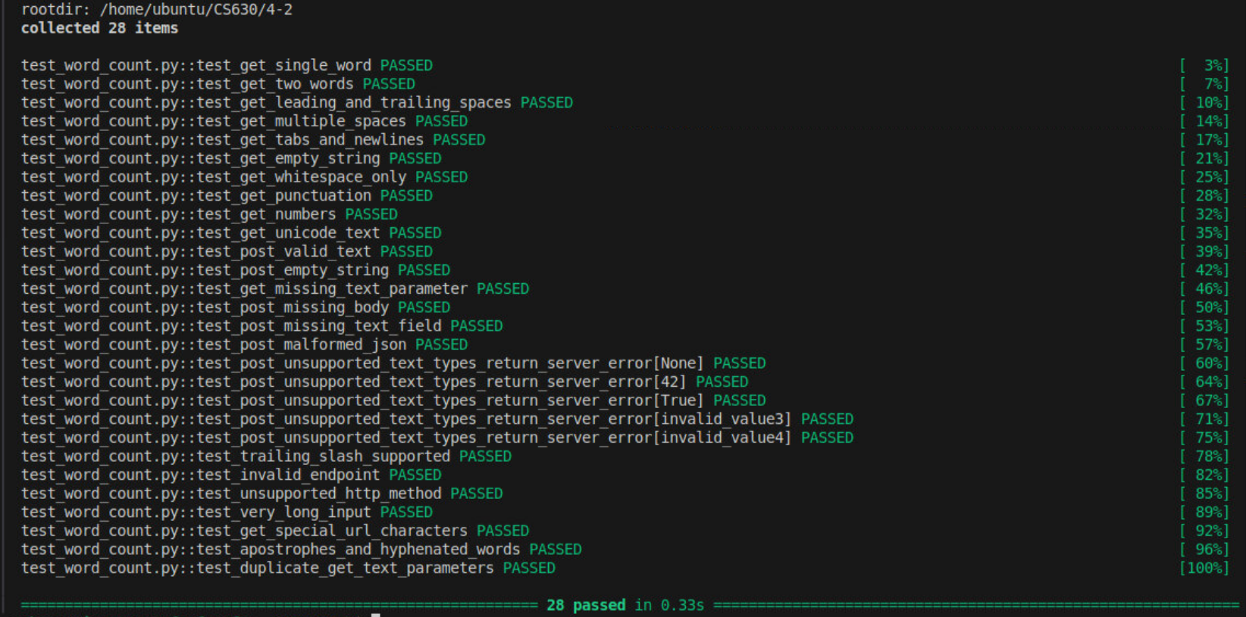
Rather than focusing only on normal user input, I designed and executed 28 test cases that evaluated functional behavior, boundary conditions, invalid inputs, routing behavior, stress conditions, and additional interface scenarios involving URL encoding, punctuation, and duplicate query parameters. These tests included empty strings, whitespace-only strings, multiple spaces, tabs, newline characters, Unicode text, missing parameters, malformed JSON, unsupported data types, invalid endpoints, unsupported HTTP methods, and a very large input containing 10,000 words. The results demonstrated that the API correctly handled both expected and unexpected requests according to its current implementation while also revealing opportunities to strengthen input validation for unsupported data types. All 28 test cases passed successfully in 0.33 seconds.
How Edge-Case Testing Improves Reliable Systems
Edge-condition testing is essential because software rarely fails during normal operation. Most production failures occur when applications receive unexpected, incomplete, or invalid input from users or other systems. By identifying these conditions before deployment, quality assurance teams can improve the reliability, stability, and security of an application while reducing the likelihood of defects in production.
This activity also reinforced the importance of defensive programming. Although the API correctly handled many invalid requests by returning appropriate HTTP status codes, unsupported input types resulted in server exceptions that produced HTTP 500 responses. While this behavior matched the current implementation, validating input types before processing them would allow the API to return a more appropriate HTTP 400 Bad Request response. Providing clear validation and meaningful error messages improves the developer experience, simplifies troubleshooting, and prevents unnecessary server-side errors.
Overall, this activity demonstrated that API testing extends beyond verifying functionality. A comprehensive testing strategy evaluates how an application behaves under normal conditions, boundary conditions, invalid input, and stress. Identifying these situations early helps produce software that is more reliable, easier to maintain, and better prepared for real-world use. This activity demonstrated that effective API testing combines functional verification with risk analysis, allowing quality assurance teams to identify weaknesses before software is released into production.

